Challenge: Snowman

As a challenge, try to create a snowman using multiple mesh instance 3D nodes. Use the selection,

move, rotate, and scale tools. Have a look at the image below to attempt it.

Example:

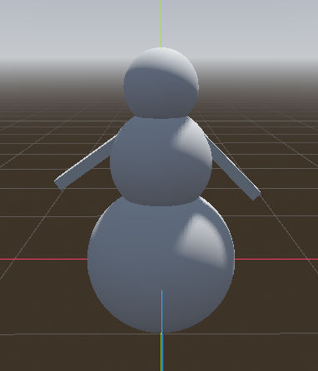

Your Snowman:

|  |
| --- |